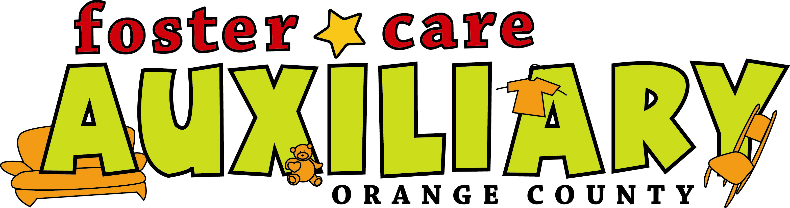

2012 FCAOC Report and Impact in our community

Activities and Services
Family Distribution available to all member families
(average of 70 participants each month with 80 Birthdays, and 6 Trials)
86 social worker referrals filled for 160 children, 16 ER Worker referrals filled for 48 children
Pastry donation program every Saturday continues for 20-30 families each week
Books continue to be available to borrow on foster care and childcare related issues
Baby Gear Loaner Program available to Foster Parents & Relative Caregivers
Partnership with Hear the Music, Live Foundation allowed concert opportunities for foster families
Able to provide tickets for ballet, plays and other events in the community
Able to provide a variety of family events, including the foster family picnic
Able to provide gifts to member families at holiday
Able to provide 6 foster youth with computers

Scholarships
Able to provide 2 former foster youth with $500 scholarships

Able to Share Product With
44 Former Foster Youth with 12 minors were referred from OCF Resource Center
48 Family Resource Center Referrals ($1,260)

Volunteer Hours
CourtOrder Community Service -over 2,220 hours

Fundraisers Over $10,645

Contributions Over$ 25,380

Other Income
$5,232 Recycle
$7,329 Membership
$1,440 Saddleback Training

Pick Ups, Donations and Gifts in Kind
71 Gifts in Kind partner pick-ups were done
23 C & B pickups
Regular OCH pickups that include product for the store & the Dist. Center
49 OCF pickups, which include product for the store & the Dist. Cent
31 Mary’s Shelter
6 Private pick up
4 Pick ups from Op Santa for store and picnic

Thrift Store report
$131,130 raised in sales

